Question 8

You have a Cisco switch and a VoIP phone that needs to be placed in a voice VLAN (VLAN 20). The data for the PC should remain in a separate VLAN (VLAN 10). Configure the switch port to support both voice and data traffic

Approach

Make the connections given below.

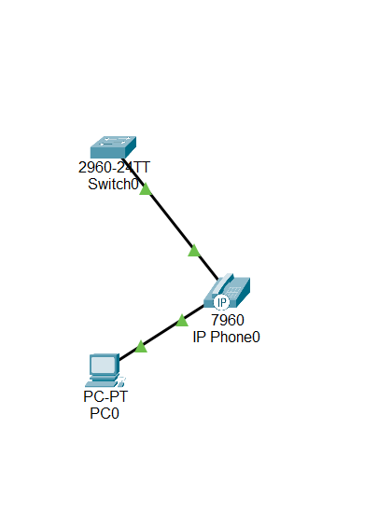

Configure the switch to have two vlan mode using below command

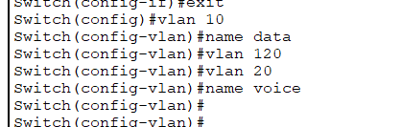



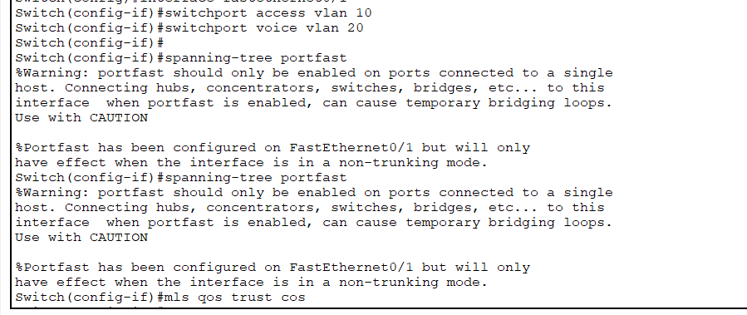

Add ip address for vlan

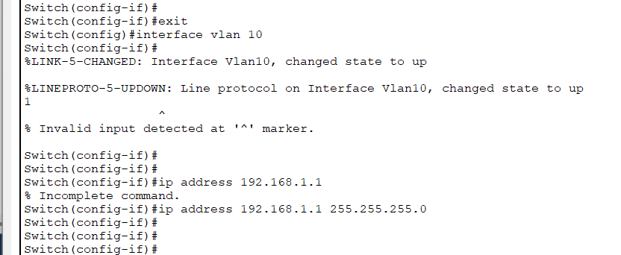

Check for vlan status

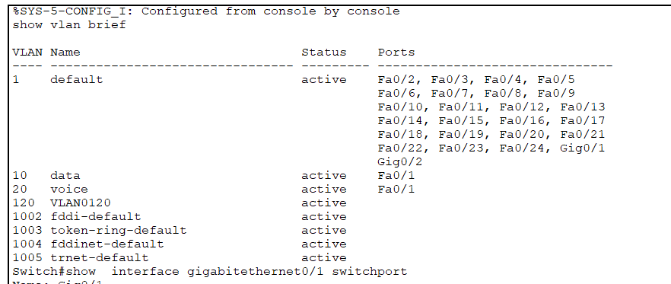

Now try to ping the router.

